December 20, 2023

Jake Chapman

ID: 21427254

Test Summary Report

Library Management System

# Test Overview

## Testing Period

November 15th, 2023 – Friday 5th January 2024

## Testing Type: [e.g., Functional Testing, Regression Testing]

* Unit
* Integration
* UI/UX
* Manual
* Non-Functional

## Test Environment: [Specify the environment details]

* IntelliJ J
* Amazon Correto JDK

# Summary of Test Activities:

## Total Test Cases:

299

* Non-Functional, Total cases = 17
* Unit, Total Cases = 132
* UI/Manual, Total cases = 133
* Integration, Total cases = 17

## Executed Test Cases:

300

## Passed Test Cases:

* Non-Functional = 17
* Unit = 78
* UI/Manual = 69
* Integration = 13

## Failed Test Cases:

* Non-Functional = 0
* Unit = 54
* UI/Manual = 64
* Integration = 4

## Test Case Pass Rate:

59%

# **Test Execution Details:**

## Testing Tools Used:

* Junit 5
* Test FX

## Execution Platform:

Mac OS

# Test Results:

## Book Unit

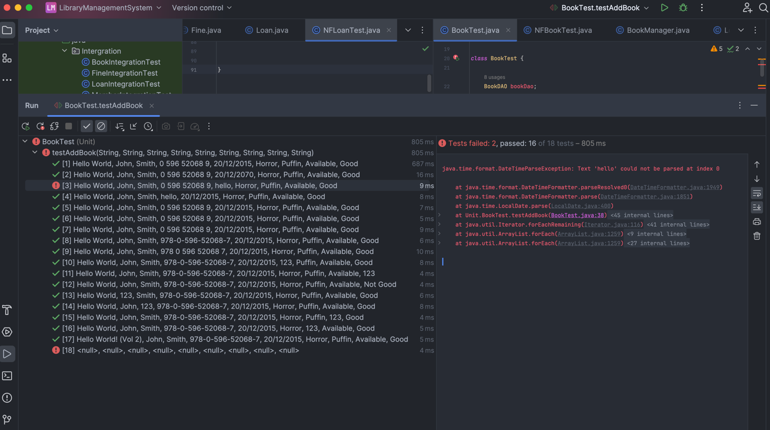

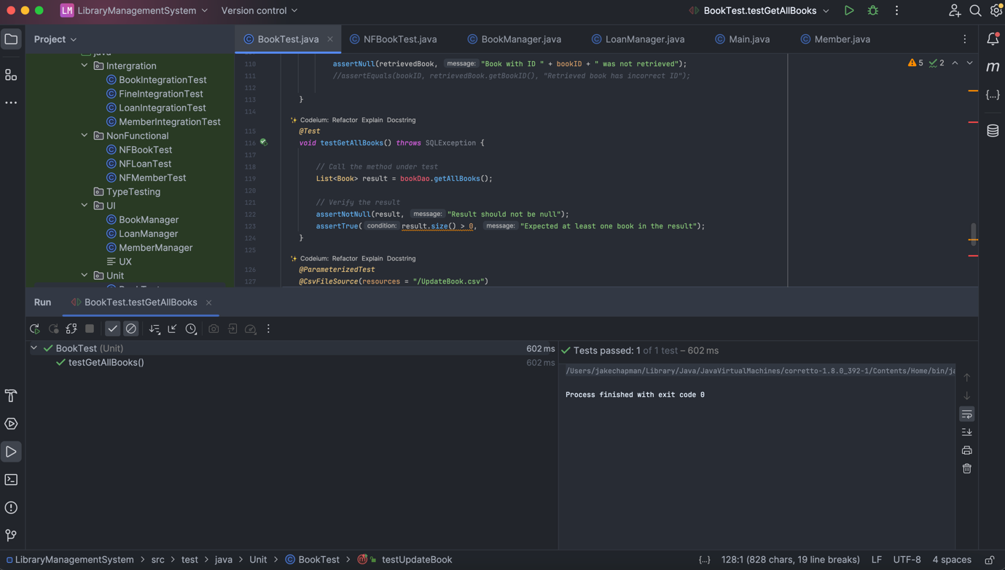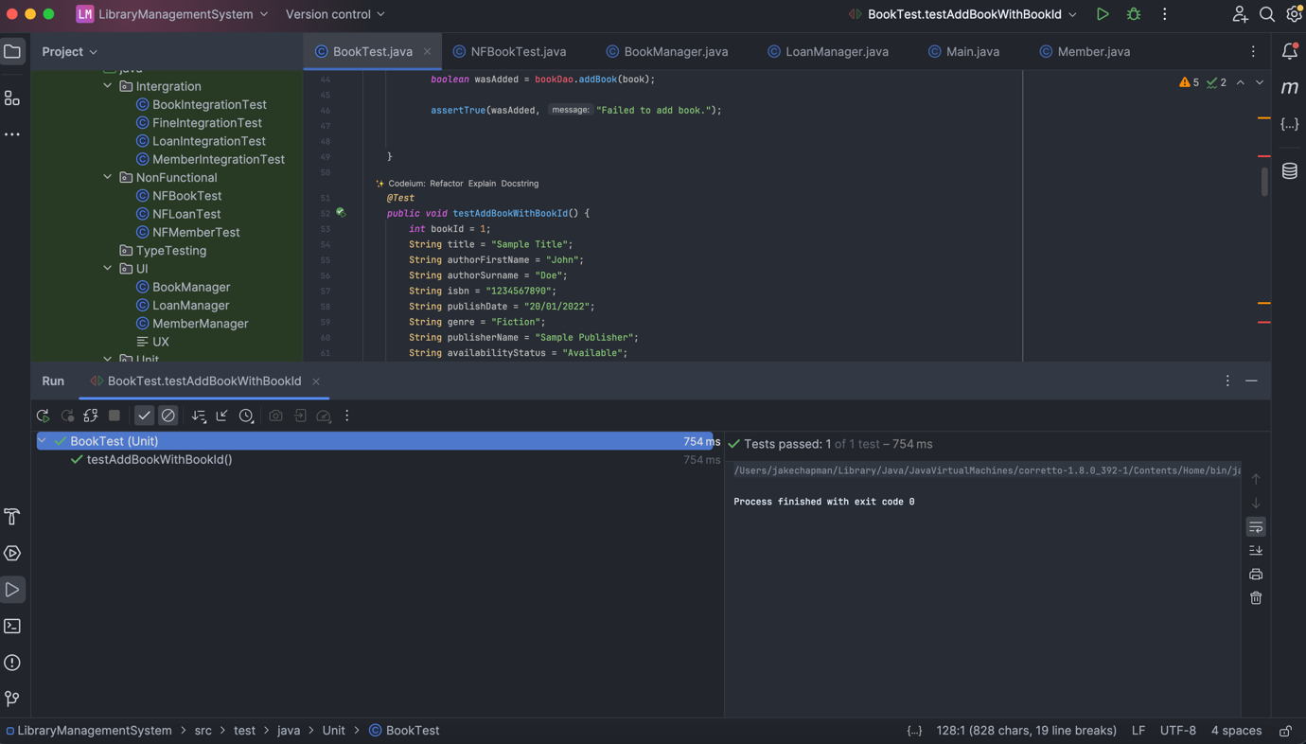

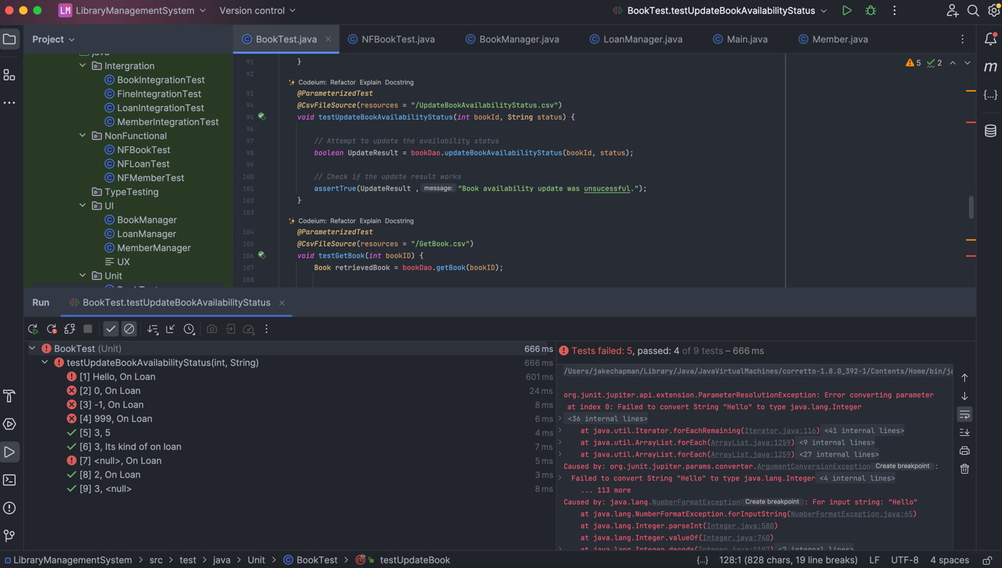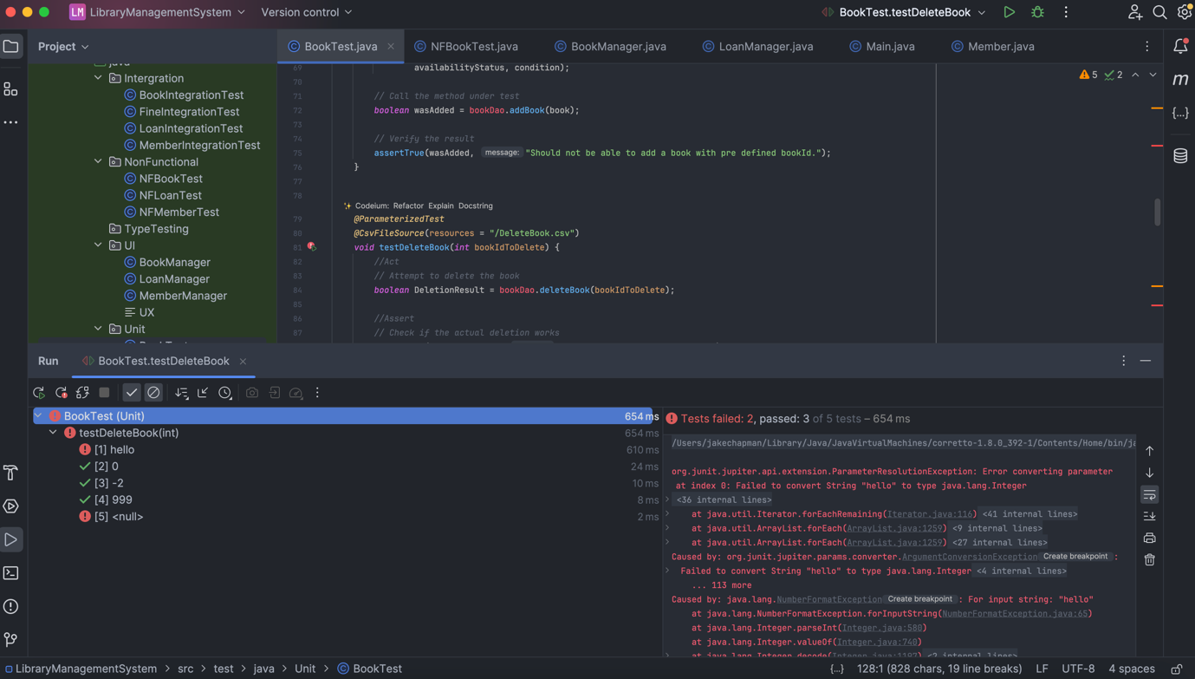

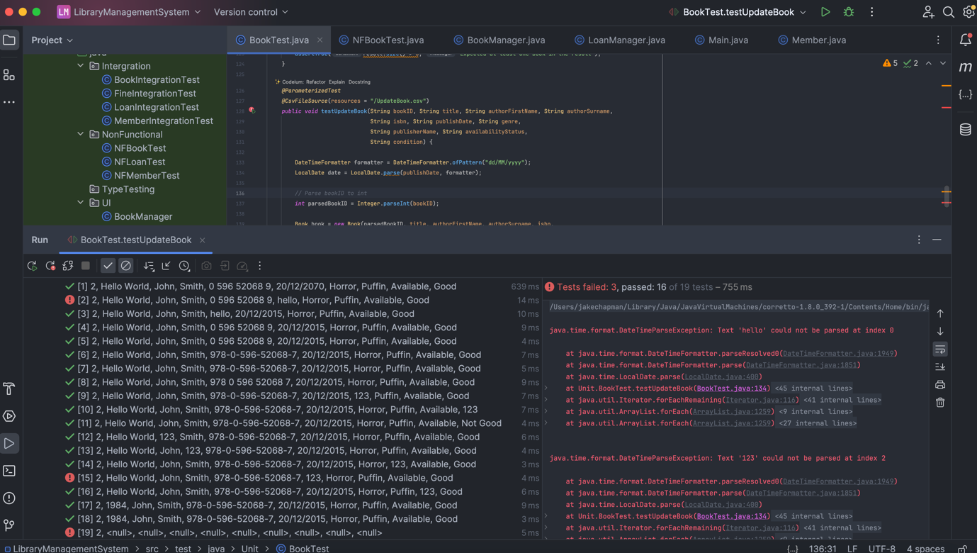

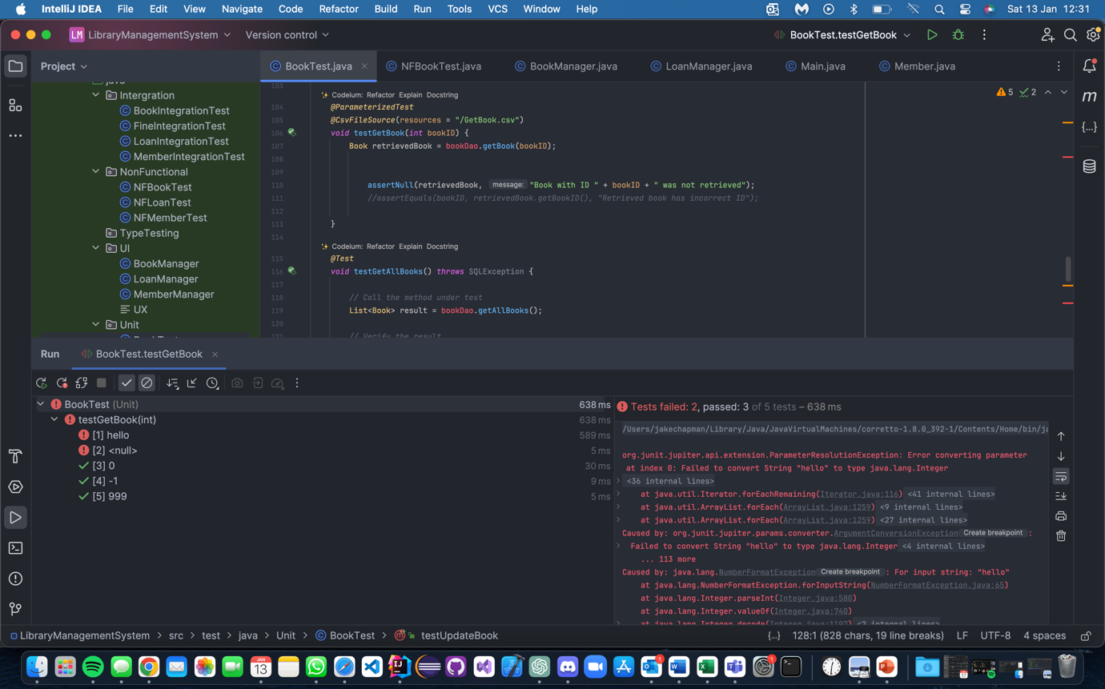

Book UI 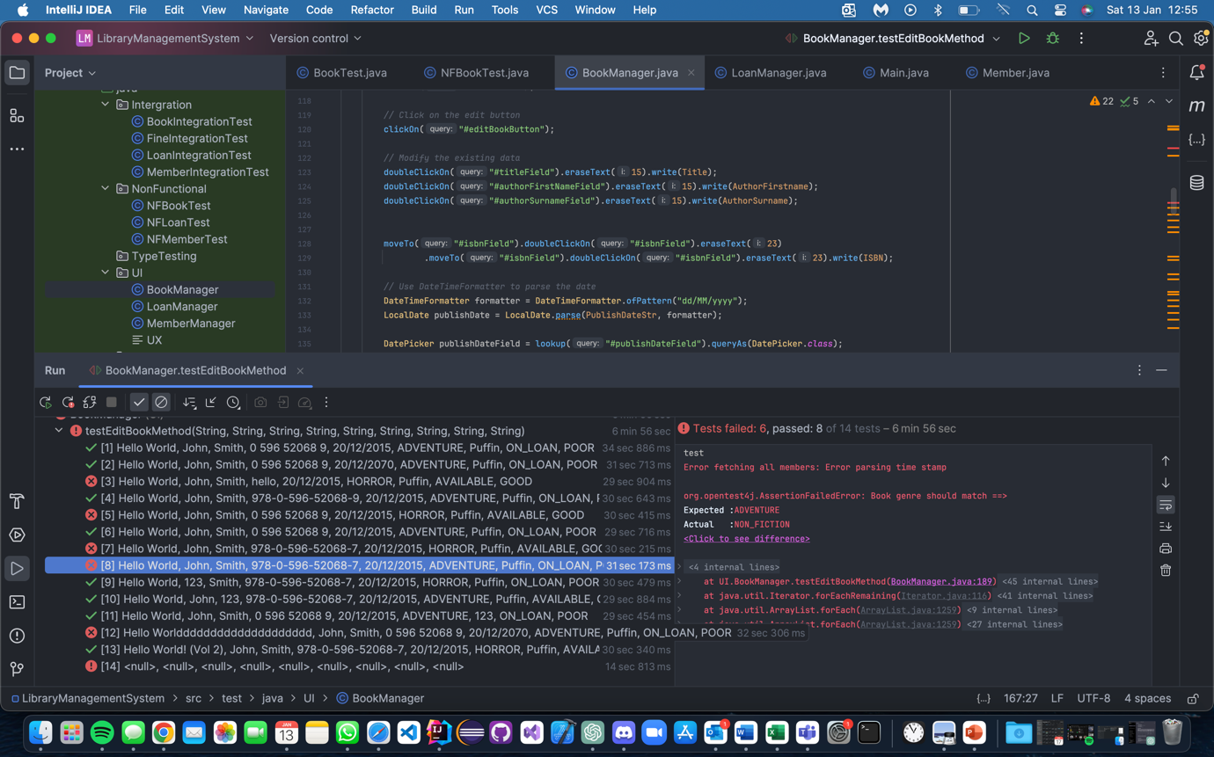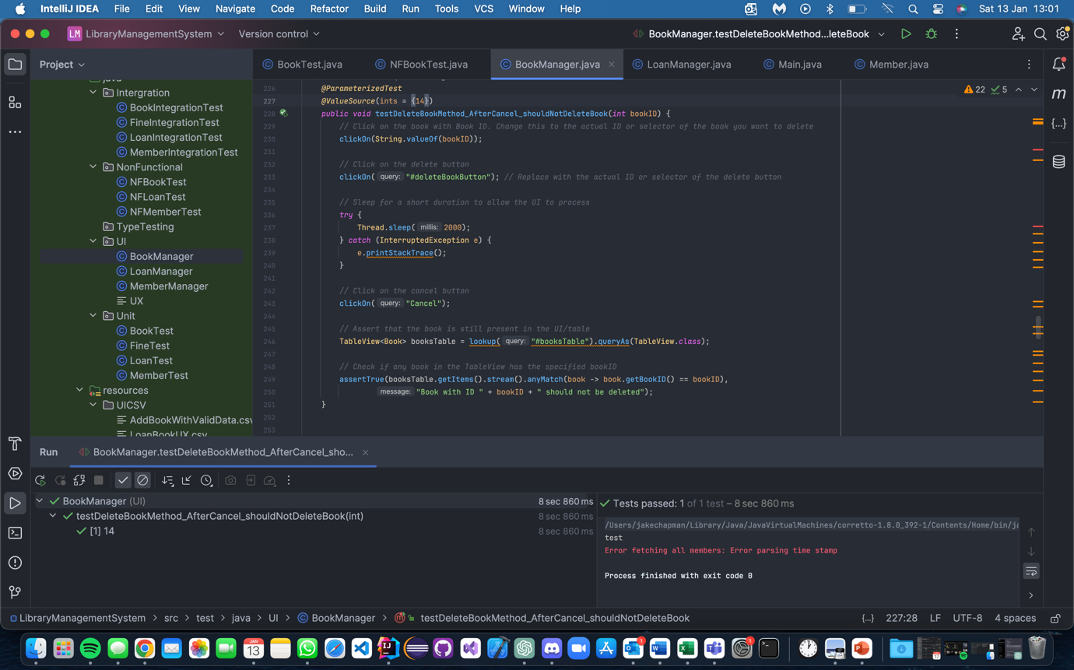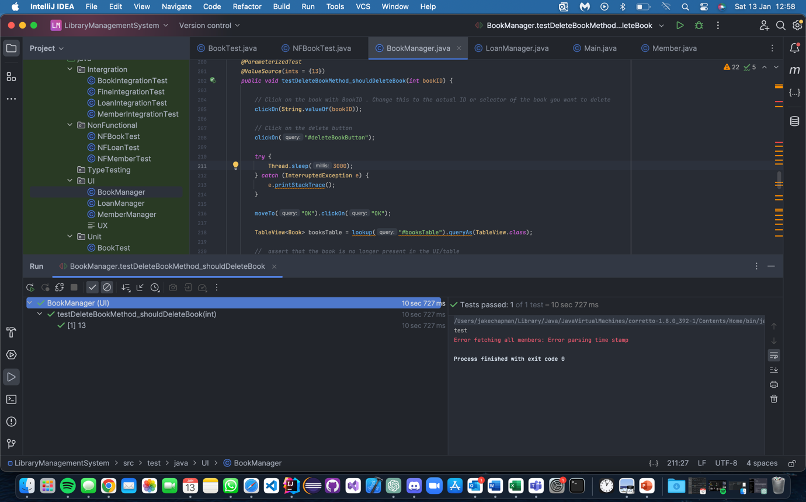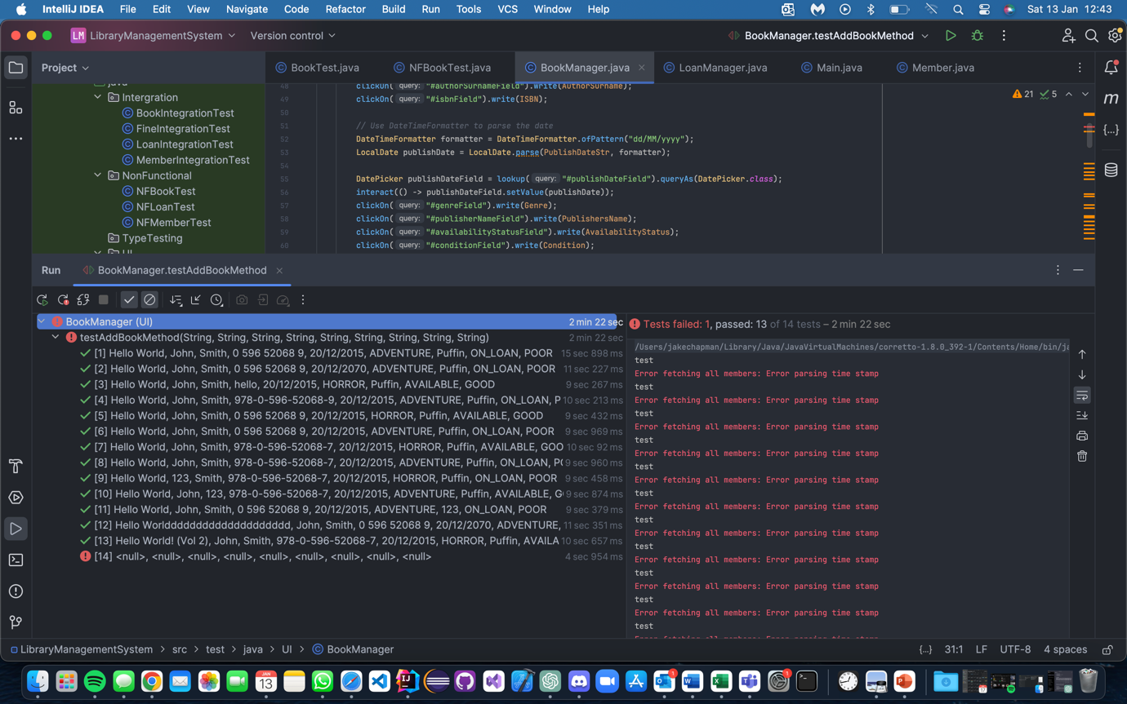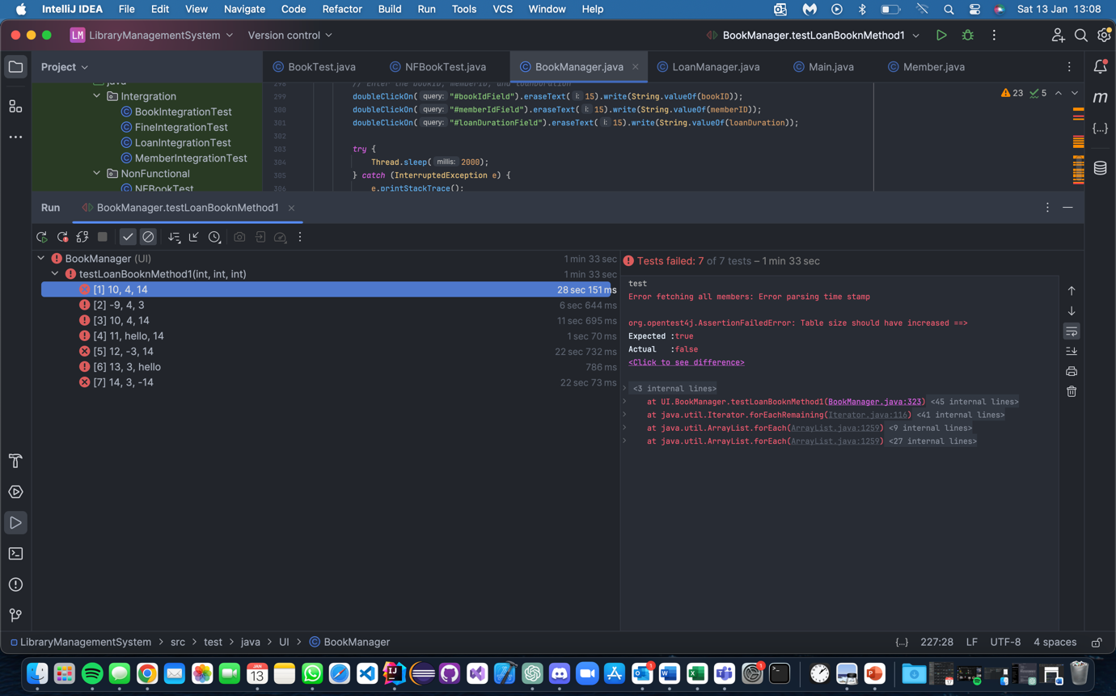

## Book Integration

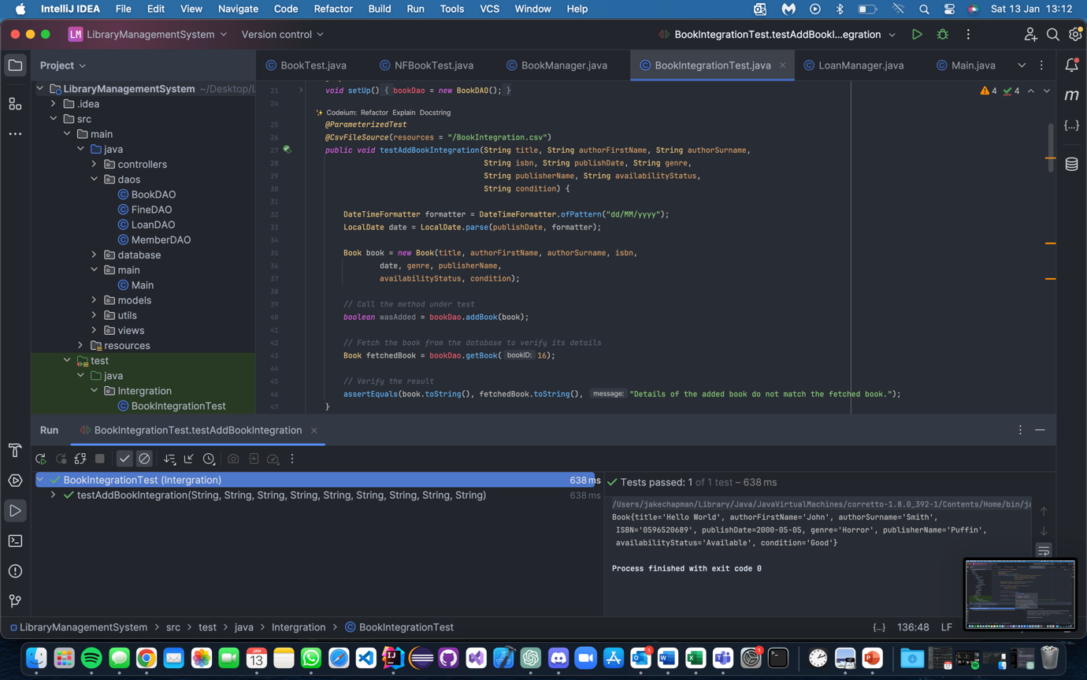

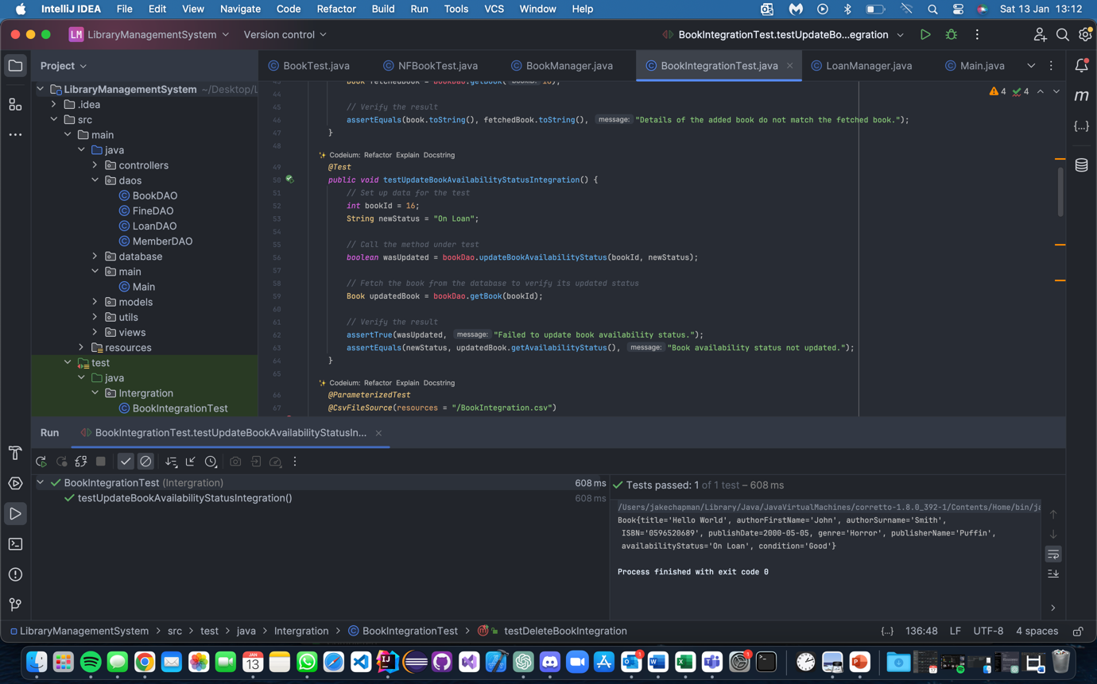

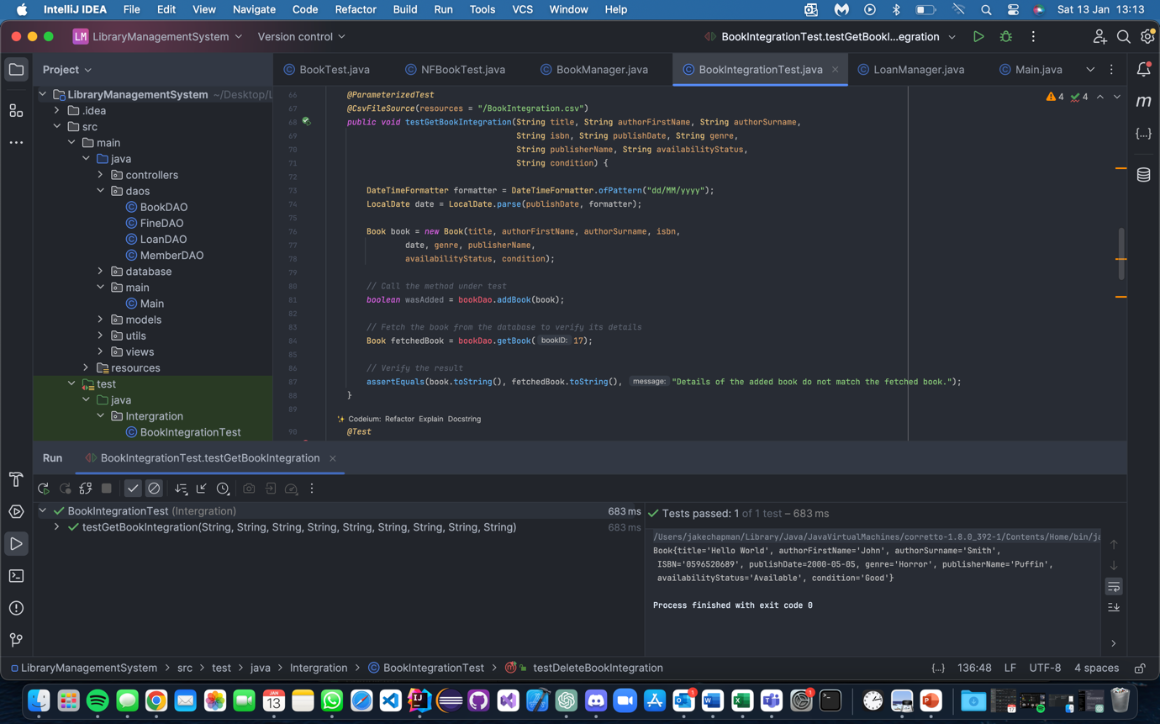

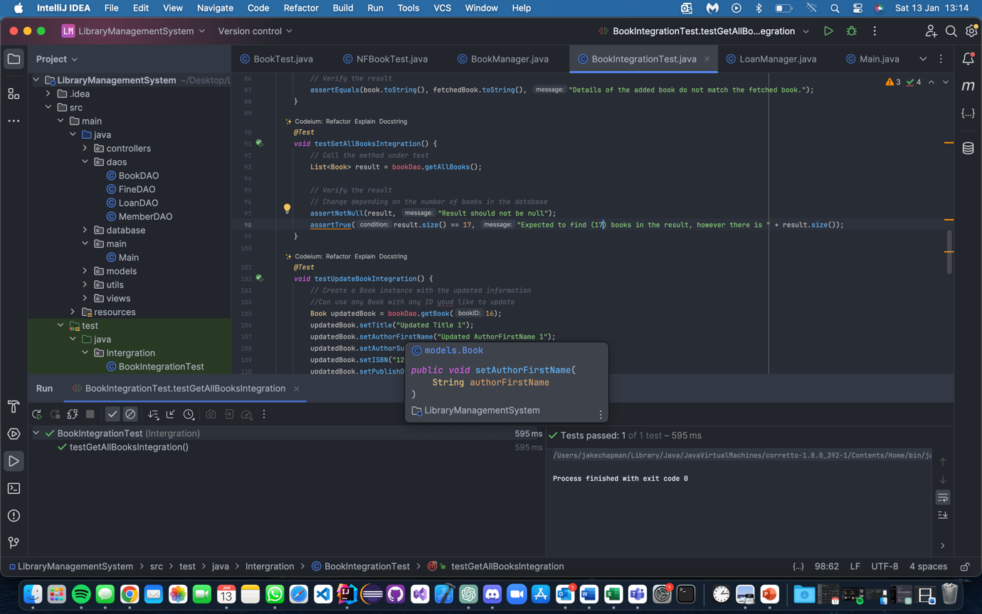

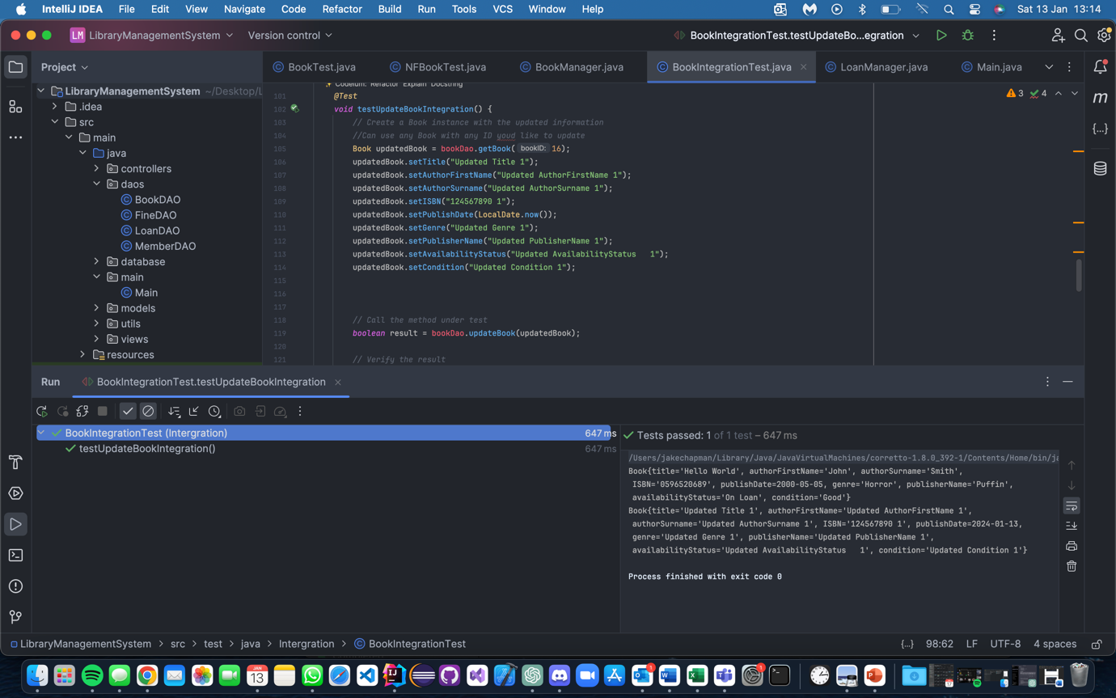

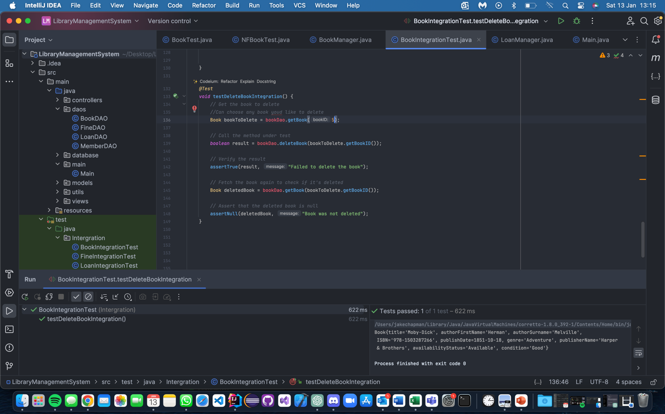

## Book Non-functional

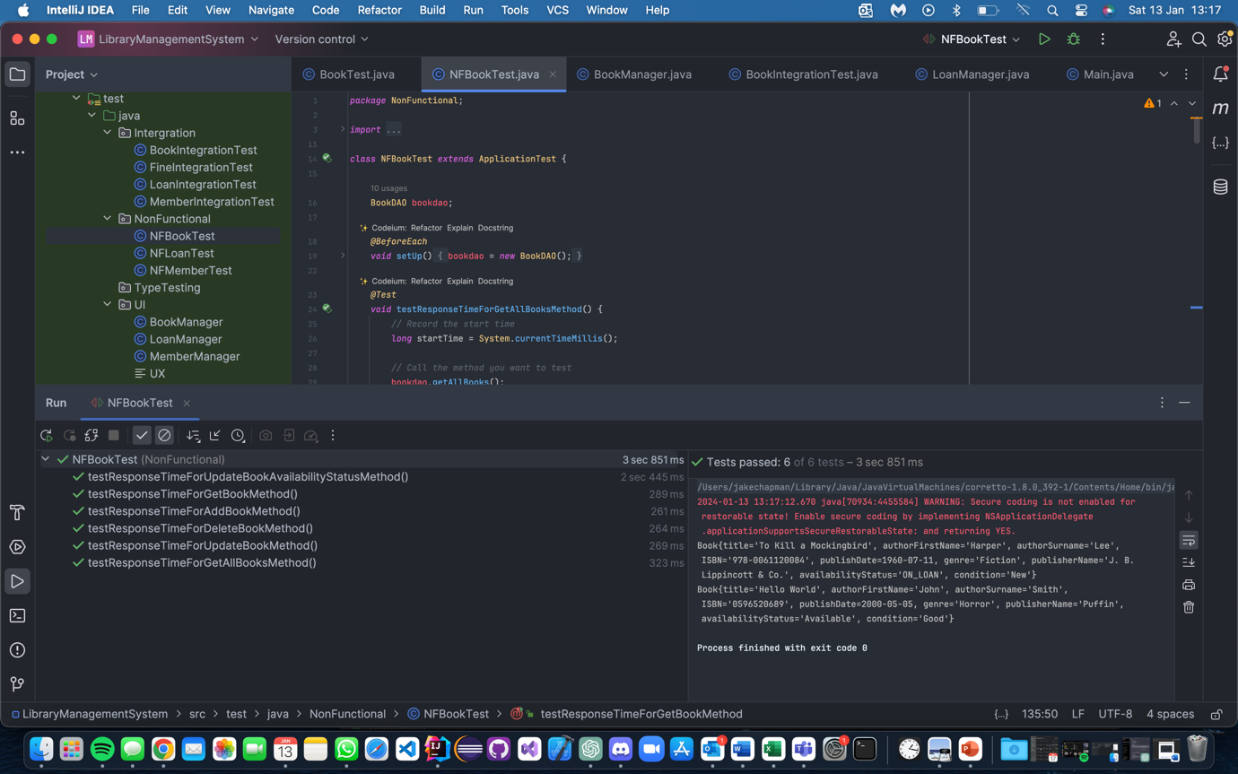

## Member Unit

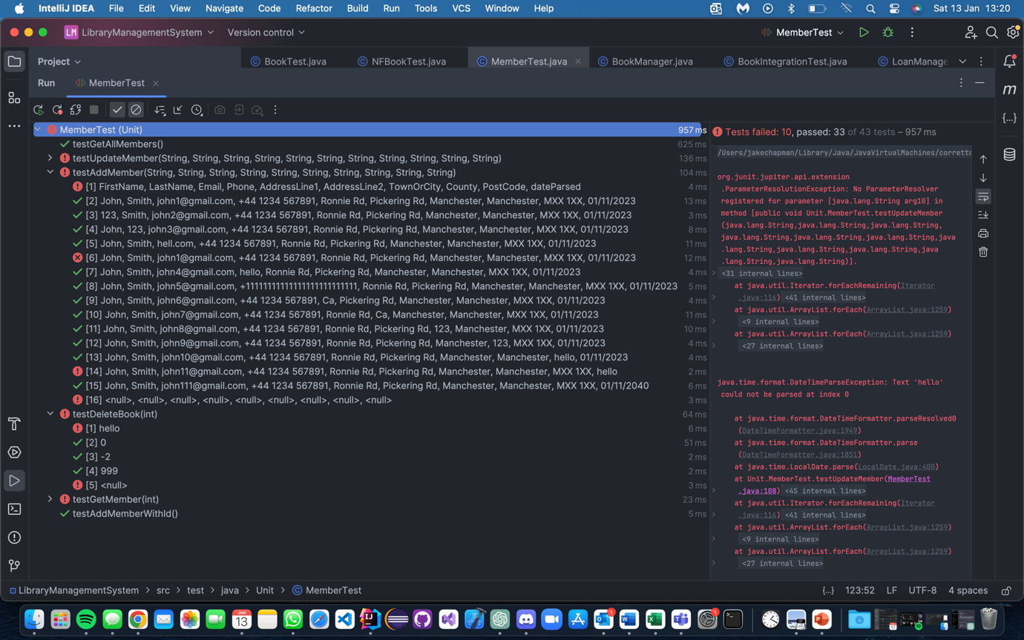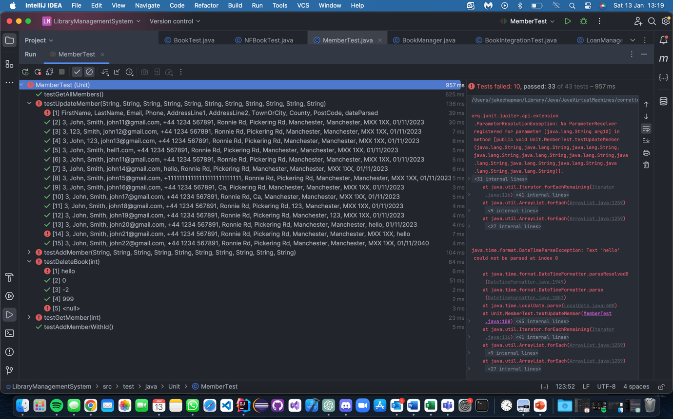

## Member UI

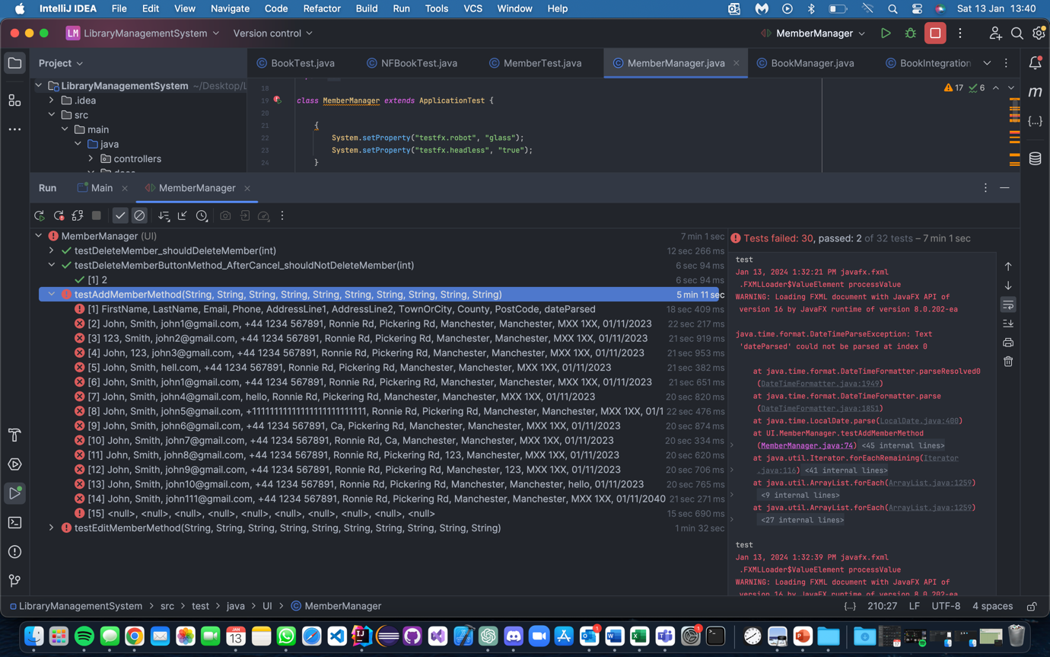

## Member Integration

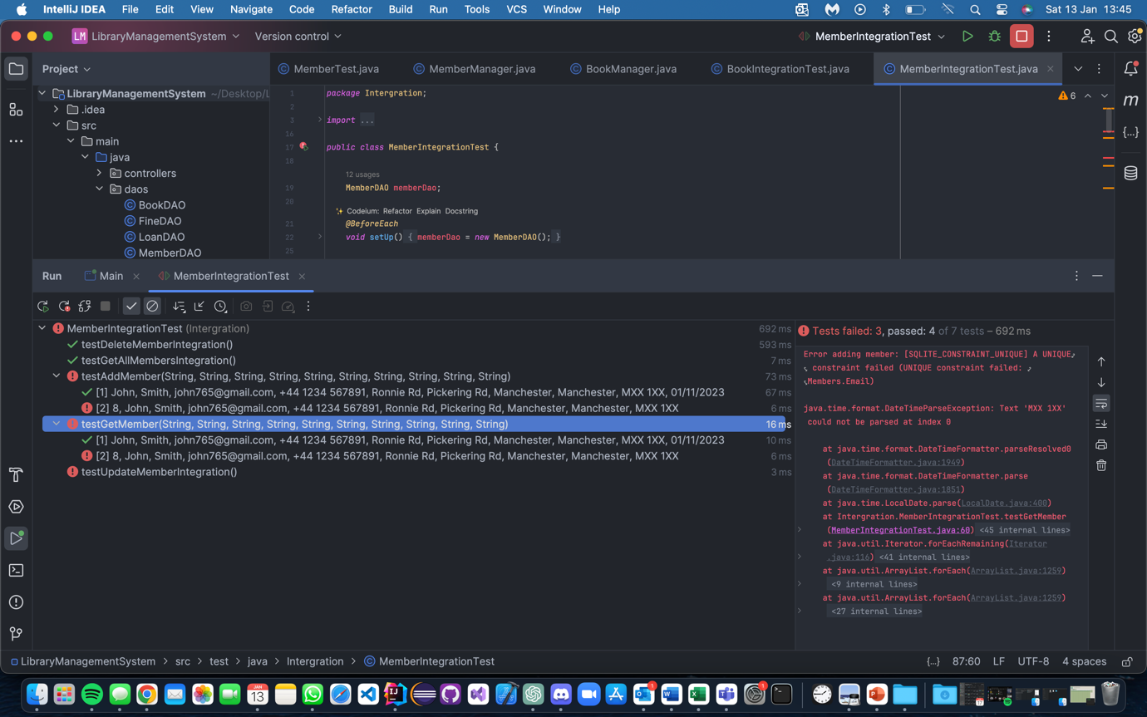

## Member Non-Functional

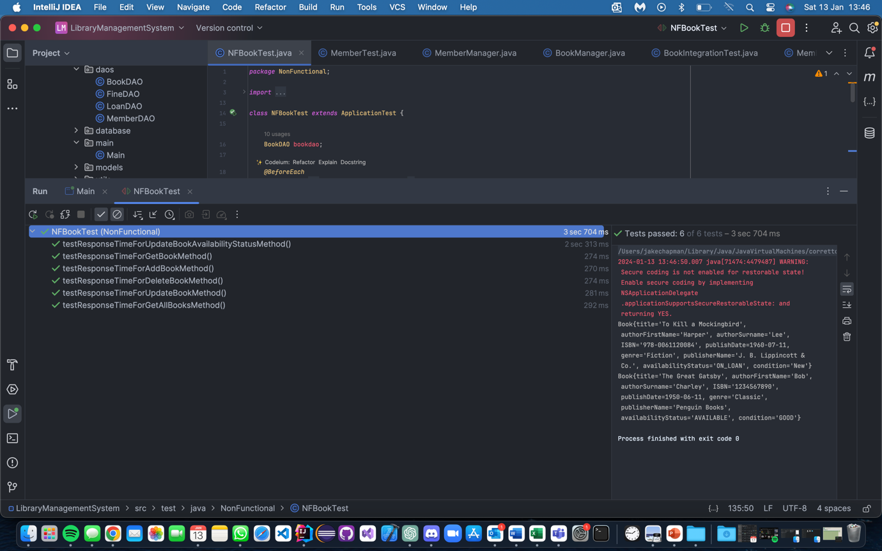

## Loan Unit

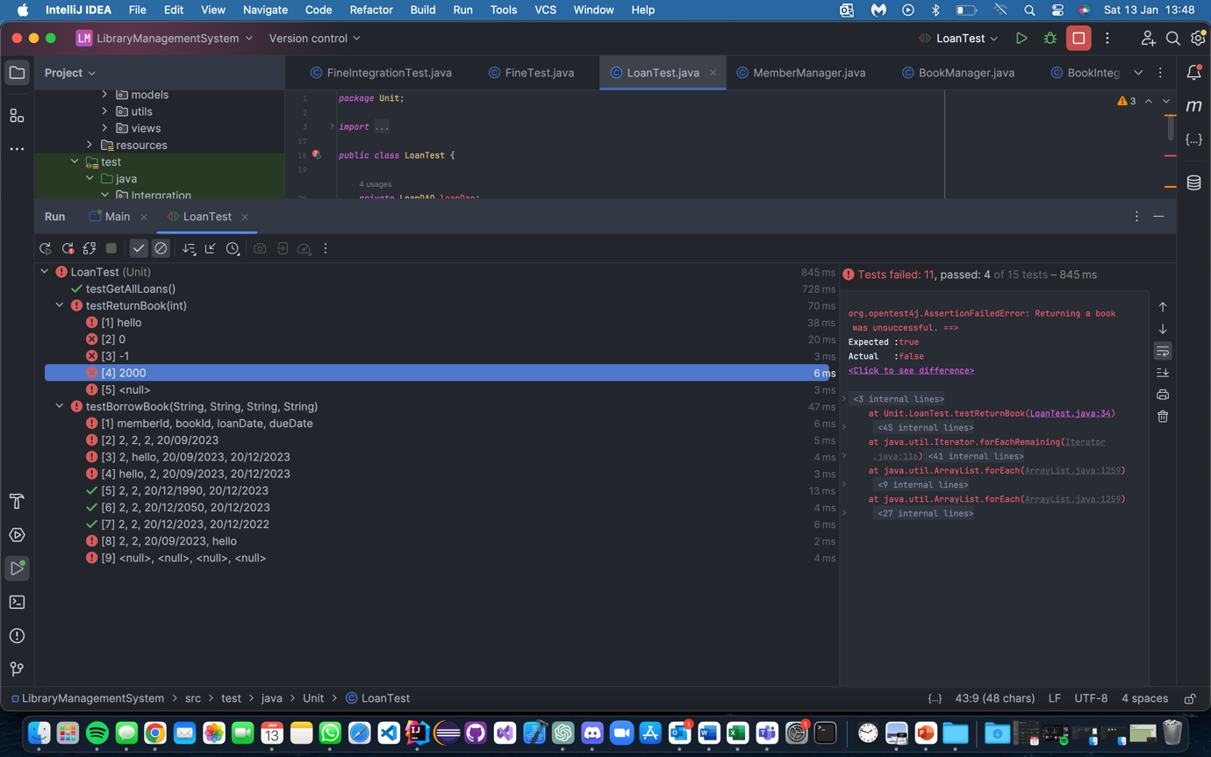

## Loan UI

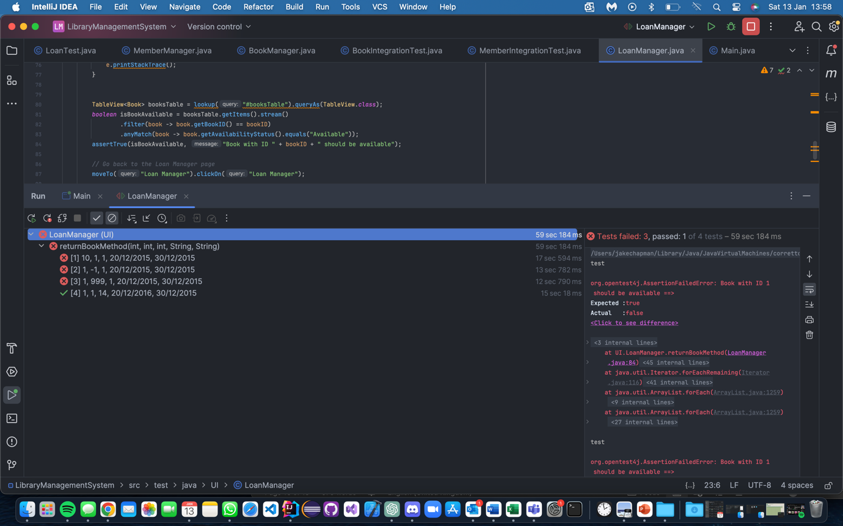

## Loan Integration

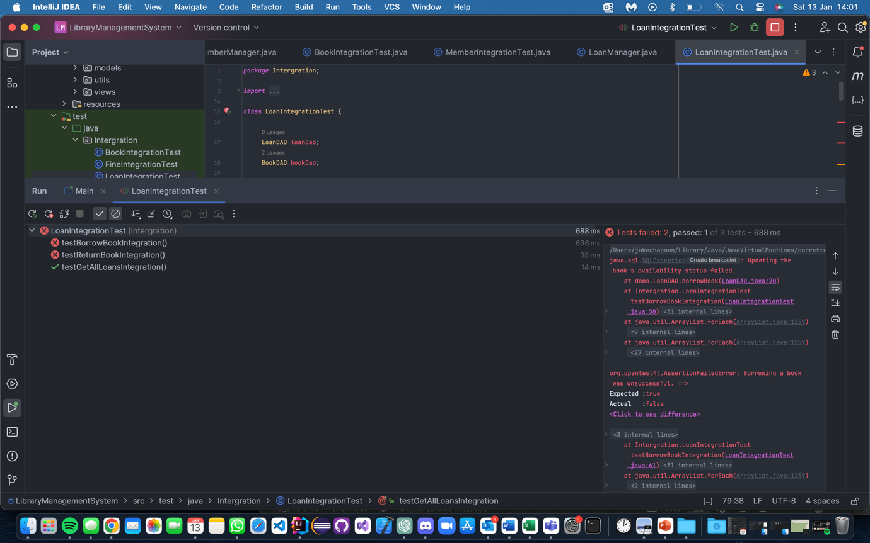

## Loan Non Functional

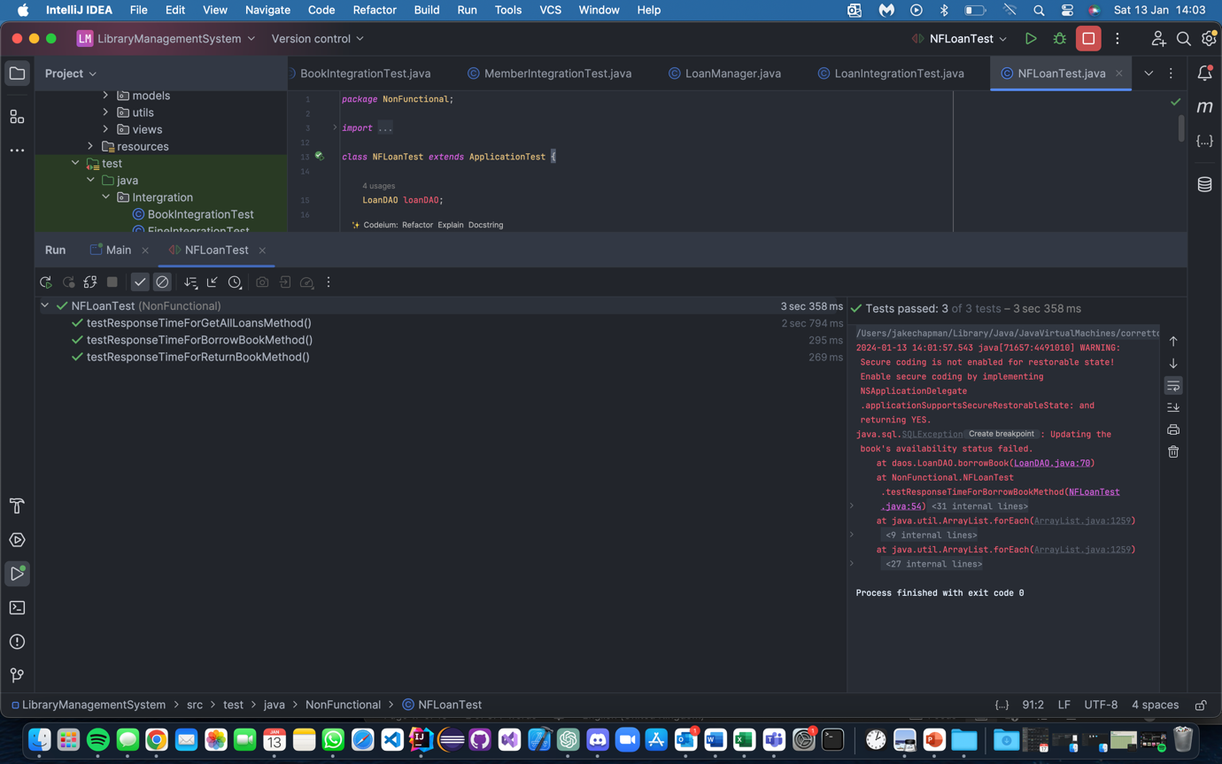

# Recommendations:

- Implement User authentication features

- Despite the systems functional requirements to have user authentication there was nothing to present in the code or UI to test this. To progress to make a comprehensive library management system it is recommended quickly.

-Database Connectivity and Methods:

- Rectify database connectivity issues, especially concerning loaning/retruing books also the Fines. The system should seamlessly reflect changes in the UI without requiring manual refresh. Ensure the reliability and responsiveness of database interactions for a smoother user experience.

Fine Management:

-Prioritise integrating the code with the database to facilitate unit testing and integration testing for core functionality and code correctness.

-Develop UI elements to enable use and access by authenticated users, such as librarians.

**Non-Functional**

-Security Implementation:

- Implement the security-related requirements outlined in the test case sheet. While the code for these features might not be present, treating them as integral requirements during testing can pave the way for future implementation and testing.

Enhance UI/UX Consistency:

- Prioritise consistency in dialog boxes and popups to ensure a clean and user-friendly experience for librarians. Address discrepancies in headers to maintain a cohesive visual language.

- Modify elements that aren't editable to align with standard UI practices. Attend to button functionalities, such as the delete button, to ensure a seamless user interface.

# Testing Approach

The approach to testing was carried out using invalid parameters/testing data. While valid data was still used in testing, using invalid data with assertions provided a more concise and informative outlook on the overall LMS. Consideration was given to test the Models, but seeing as they were just simple setters and getters, it did not seem necessary. Even if we wanted to set invalid data types, it would not be possible, the code demonstrates that and can be very clearly understood.

Firstly, we carried out Unit tests on the DAO methods. This set a good baseline for the rest of the tests. If the DAOs fail, we can assume that the integration tests will not act as expected, and neither will the UI tests, as they provide the basis for each. Some notable tests for unit tests included checking invalid parameter types (e.g., String for Double). Notably, this is where I discovered the disconnection of the database with the Fine classes.

After the Unit tests were completed, the logical conclusion was to perform the integration tests because to validate those, you need to use a combination of working DAO tests, which had just been tested with the Units. The combination was mostly a mix of the method in the test and a getter to ensure the data was added/deleted/edited correctly.

Thirdly, the tests that were done were UI/manual. The UI tests were done using TestFx. These followed a similar approach to the Unit tests, checking the text with invalid and null parameters and verifying whether the corresponding list was added/deleted/edited correctly.

The last set of tests I decided to carry out were the Non-Functional. Despite not all of them being tested, such as the security concerns, the coverage for response times was. All the DAO methods were tested for the timings, and they all passed.

# Conclusion

The evaluation highlights deliberate invalid data in select tests to gauge error handling, emphasising robust error management rather than system perfection.

The Defect Log proves invaluable for nuanced insights, detailing identified defects, their severity, and potential impacts, not just pass/fail assessments, which the Test Cases do.

The biggest concerns centre around the database connection for the fine methods, in addition there’s also issues with the database impacting system responsiveness in critical loan processes.

The separation of method code, particularly in the "Fine" methods, from the database underscores a critical need for seamless integration. Addressing this is crucial, given it aligns directly with functional system requirement. The testing process encountered limitations in assessing fine management comprehensively due to this disconnect. Resolving this issue is pivotal for delivering a conclusive response to the specific requirements of the fine management feature.

Usability issues arise from the necessity to restart the application for changes to take effect, particularly in loan transactions. An ideal system should ensure real-time updates without manual intervention, automatically revising book loan statuses.

There is also a massive lack of validation for the inputs/parameters, with many tests allowing you to leave empty data, as an example. This is where it would be required to create valid pieces of referable data.

In addition to that, there is a lack of error prompts for invalid data types, leaving users such as the librarian unaware of their mistakes. This leads to a clunky and unfriendly system.

In moving forward, it is recommend prioritising the refinement of database connections, ensuring real-time updates, and streamlining the librarian's experience. This collaborative approach aims not just to fix identified defects but to elevate the system's overall functionality and user-friendliness.